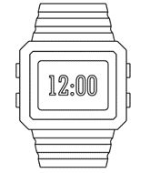

PO3_DGW_Digital watch

(GDD)

Table 1 Status Table
Document Name | Author | Version | Update Date | Status
GDD | Norhan Nassar | 1.2 | 1/03/2020 | Proposed

DOCUMENT HISTORY
Table 2 Document History
Version | Description of Change | Author | Date | Document Status
1 | Initial creation of GDD Document | Norhan Nassar | 27/01/2020 | Draft
1.1 | Adding Software input output,  Updating Software feature diagram and updating static layered architecture | Norhan Nassar | 1/03/2020 | Proposed
1.2 | Adding Requirement at LCD Component  Req_PO3_DGW_GDD_11_V01.0 and shifting other Requirements ids | Norhan Nassar | 4/03/2020 | Proposed

Table 3 Reference Table
Reference Input Documents | Version | Status
SRS | 1.7 | Proposed
HIS | 1.5 | Released

Project Description
Digital Watch System that has three different modes.
- Time Display Mode that displays the time as a normal clock and increments its time every 1 second.
- Alarm Mode that it turns a buzzer on when time is on.
- Stopwatch Mode.
The user can select an option of these three modes.

Software Context Diagram
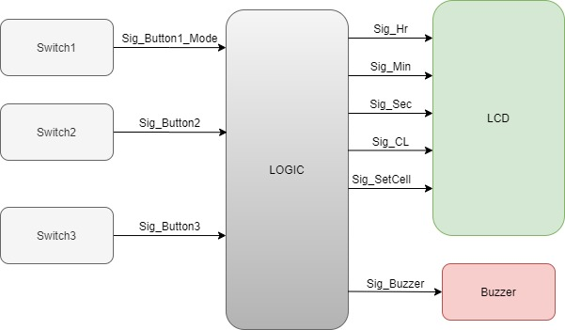

Input Output Signals
3.1 Input Output Diagram
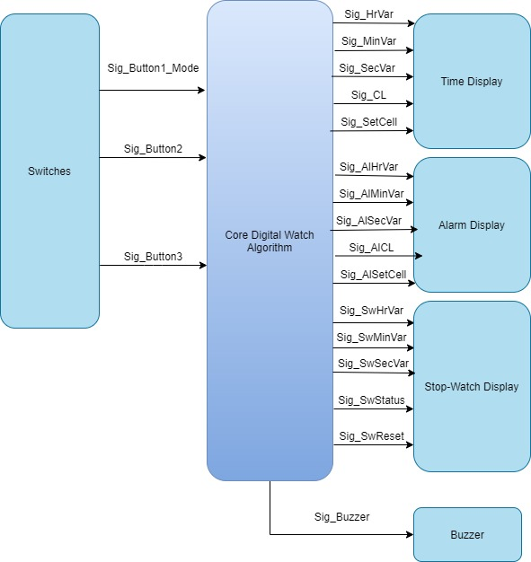

3.2 Input output Table
Inputs | Name | Range |  | Unit
Inputs | Sig_Button1_Mode | 0:2 | NA
Inputs | Sig_Button2 | 0:1 | NA
 | Sig_Button3 | 0:1 | NA
 | Sig_HrVar | 0:12 | Time-Hours
 | Sig_MinVar | 0:60 | Time-Minutes
 | Sig_SecVar | 0:60 | Time_Seconds
 | Sig_CL | 0:1 | Am/Pm
 | Sig_SetCell | 0:16 | NA
 | Sig_AlHrVar | 0:12 | Time-Hours
 | Sig_AlMinVar | 0:60 | Time-Minutes
 | Sig_AlSecVar | 0:60 | Time-Seconds
 | Sig_AlCL | 0:1 | Am/Pm
 | Sig_AlSetCell | 0:16 | NA
 | Sig_SwHrVar | 0:12 | Time-Hours
 | Sig_SwMinVar | 0:60 | Time-Minutes
 | Sig_SwSecVar | 0:60 | Time-Seconds
 | Sig_Status | 0:1 | NA
 | Sig_Reset | 0:1 | NA
 | Sig_SecVar | 0:60 | Time-Seconds
Outputs | Name | Range | Unit
 | Sig_Buzzer | 0:1 | NA

Software Feature:
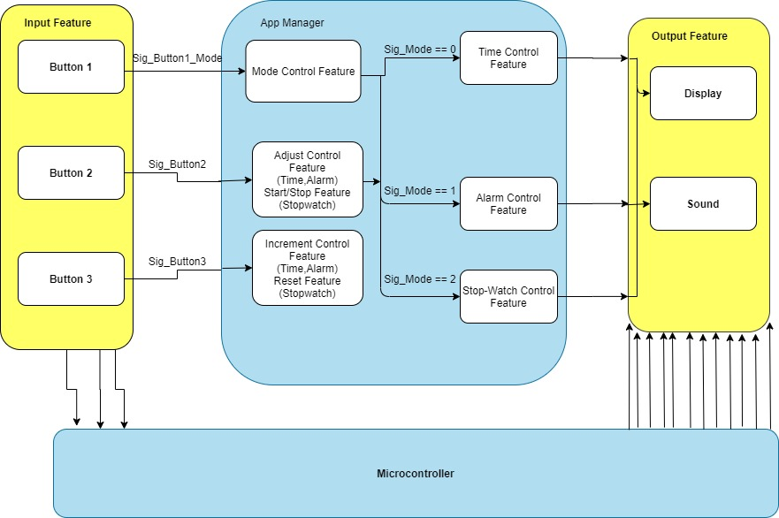

Static Architecture:
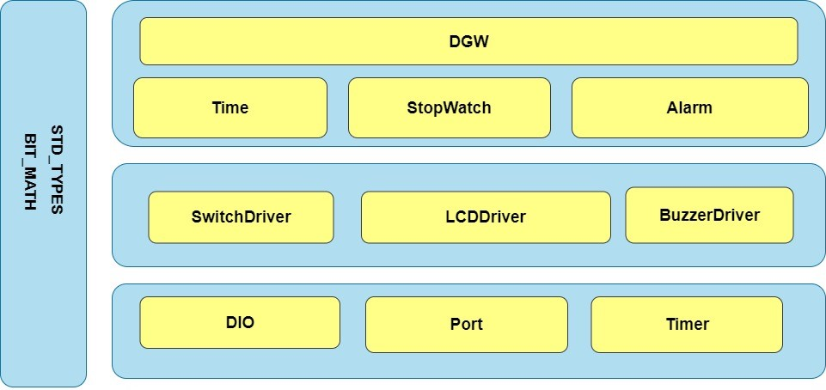

Requirements

6.1 MCAL Layer:

6.1.1 DIO Component:

Req_ID | Req_PO3_DGW_GDD_01_V01.0 |  | Covers |  | All SRS Requirements Signals need to be mapped to certain Port and direction.
Author | Norhan Nassar |  | Date | 1/03/2020
Description: | Set Pin Direction for certain Port
API | DIO_voidSetPinDirection(u8 Copy_u8Port,u8 Copy_u8Pin, u8 Copy_u8Direction)
Parameters | Type | Name |  |  | Description
Parameters | u8  u8  u8 | Copy_u8Port  Copy_u8Pin  Copy_u8Direction |  |  | Port from A to D  Pin from 0 to 7  Output -> 1 or input -> 0
Return | Type | Name |  |  | Description
Return | void | _____ |  |  | _____

Req_ID | Req_PO3_DGW_GDD_02_V01.0 |  | Covers |  | Req_PO3_DGW_SRS_03_V01.2  Req_PO3_DGW_SRS_06_V01.2  Req_PO3_DGW_SRS_07_V01.2  Req_PO3_DGW_SRS_22_V01.2
Author | Norhan Nassar |  | Date | 1/03/2020
Description: | Set or Reset Pin at certain port  Value -> 1 to set it high  Value -> 0 to reset it to low
API | DIO_voidSetPinValue(u8 Copy_u8Port,u8 Copy_u8Pin, u8 Copy_u8Value);
Parameters | Type | Name |  |  | Description
Parameters | u8  u8  u8 | Copy_u8Port  Copy_u8Pin  Copy_u8Value |  |  | Port from A to D  Pin from 0 to 7  Value -> 1 to set Pin high  Value -> 0 to set Pin low
Return | Type | Name |  |  | Description
Return | void | _____ |  |  | _____

Req_ID | Req_PO3_DGW_GDD_03_V01.0 |  | Covers |  | Req_PO3_DGW_SRS_04_V01.2  Req_PO3_DGW_SRS_09_V01.2  Req_PO3_DGW_SRS_14_V01.2  Req_PO3_DGW_SRS_19_V01.2  Req_PO3_DGW_SRS_20_V01.2  Req_PO3_DGW_SRS_21_V01.2  Req_PO3_DGW_SRS_23_V01.2  Req_PO3_DGW_SRS_24_V01.2  Req_PO3_DGW_SRS_25_V01.2
Author | Norhan Nassar |  | Date | 1/03/2020
Description: | Get Pin value at certain Port  1 -> High  0 -> Low
API | DIO_u8GetPinVal(u8 Copy_u8Port,u8 Copy_u8Pin)
Parameters | Type | Name |  |  | Description
Parameters | u8  u8 | Copy_u8Port  Copy_u8Pin |  |  | Port from A to D  Pin from 0 to 7
Return | Type | Name |  |  | Description
Return | u8 | _____ |  |  | Return <- Status of the Pin

6.1.2 Port Component:

Req_ID | Req_PO3_DGW_GDD_04_V01.0 |  | Covers |  | All SRS Requirements Signals need to be mapped to certain Port and direction.
Author | Norhan Nassar |  | Date | 1/03/2020
Description: | It initialize each Port and Pins to be output or input according to Port_config file  Output -> 1 Input -> 0
API | Port_voidInitialize(void);
Parameters | Type | Name |  |  | Description
Parameters | void | _____ |  |  | _____
Return | Type | Name |  |  | Description
Return | void | _____ |  |  | _____

6.1.3 Timer Component:

Req_ID | Req_PO3_DGW_GDD_05_V01.0 |  | Covers |  | Req_PO3_DGW_SRS_01_V01.2  Req_PO3_DGW_SRS_02_V01.2  Req_PO3_DGW_SRS_20_V01.2
Author | Norhan Nassar |  | Date | 27/2/2020
Description: | It makes Timer start to increment.
API | Timer_voidInit(void)
Parameters | Type | Name |  |  | Description
Parameters | void | _____ |  |  | _____
Return | Type | Name |  |  | Description
Return | void | _____ |  |  | _____

Req_ID | Req_PO3_DGW_GDD_06_V01.0 |  | Covers |  | Req_PO3_DGW_SRS_01_V01.2  Req_PO3_DGW_SRS_02_V01.2  Req_PO3_DGW_SRS_20_V01.2
Author | Norhan Nassar |  | Date | 27/2/2020
Description: | It will display HrVar, MinVar, Secvar and CycleLength  And it will take which cell to display onto the LCD the it called LCD  to write these data onto this location.
API | Timer_voidSetCallBack(void(*Copy_pvCallBackPtr)(void))
Parameters | Type | Name |  |  | Description
Parameters | void (*) (void) | Copy_pvCallBackPtr |  |  | Pointer to function that it will be implemented when Interrupt has been happened.
Return | Type | Name |  |  | Description
Return | void | _____ |  |  | _____

6.2 HAL Layer:

6.2.1 Switch Component:
Req_ID | Req_PO3_DGW_GDD_07_V01.0 |  | Covers |  | Req_PO3_DGW_SRS_09_V01.2  Req_PO3_DGW_SRS_10_V01.2  Req_PO3_DGW_SRS_14_V01.2  Req_PO3_DGW_SRS_21_V01.2  Req_PO3_DGW_SRS_23_V01.2  Req_PO3_DGW_SRS_24_V01.2  Req_PO3_DGW_SRS_25_V01.2
Author | Norhan Nassar |  | Date | 27/2/2020
Description: | Get Switch state according to its config file that it configures its Port and pin to get its status
API | Switch_u8GetState (u8 Copy_u8SwNum)
Parameters | Type | Name |  |  | Description
Parameters | u8 | Copy_u8SwNum |  |  | Switch Number to get state of a certain switch
Return | Type | Name |  |  | Description
Return | u8 | _____ |  |  | Return = State of the switch according to Switch_config file  Pressed will represent 0 or 1  If RELEASE_STATE defined as 1  So pressed will represent 0  If RELEASE_STATE defined as 0  So pressed will represent 1

6.2.2 Buzzer Component:

Req_ID | Req_PO3_DGW_GDD_09_V01.0 |  | Covers |  | Req_PO3_DGW_SRS_03_V01.2  Req_PO3_DGW_SRS_04_V01.2
Author | Norhan Nassar |  | Date | 27/2/2020
Description: | It sets buzzer state according to its config file that it congiures its port and pin.
API | Buzzer_voidSetState(u8 State)
Parameters | Type | Name |  |  | Description
Parameters | u8 | State |  |  | Buzzer state to set its pin to this state  High -> 1  Low -> 0
Return | Type | Name |  |  | Description
Return | void | _____ |  |  | _____

6.2.3 LCD Component:

Req_ID | Req_PO3_DGW_GDD_10_V01.0 |  | Covers |  | Req_PO3_DGW_SRS_06_V01.2  Req_PO3_DGW_SRS_08_V01.2
Author | Norhan Nassar |  | Date | 27/2/2020
Description: | Initialize LCD according to its datasheet.
API | CLCD_voidInitialize(void)
Parameters | Type | Name |  |  | Description
Parameters | void | _____ |  |  | _____
Return | Type | Name |  |  | Description
Return | void | _____ |  |  | _____

Req_ID | Req_PO3_DGW_GDD_11_V01.0 |  | Covers |  | Req_PO3_DGW_SRS_06_V01.2  Req_PO3_DGW_SRS_08_V01.2
Author | Norhan Nassar |  | Date | 27/2/2020
Description: | Select command to do at LCD → from its data sheet.
API | CLCD_voidWriteCmd(u8 Copy_u8Cmd)
Parameters | Type | Name |  |  | Description
Parameters | u8 | Copy_u8Cmd |  |  | Command for LCD
Return | Type | Name |  |  | Description
Return | void | _____ |  |  | _____

Req_ID | Req_PO3_DGW_GDD_12_V01.0 |  | Covers |  | Req_PO3_DGW_SRS_06_V01.2  Req_PO3_DGW_SRS_08_V01.2
Author | Norhan Nassar |  | Date | 27/2/2020
Description: | Set data on data port of the LCD.
API | CLCD_voidWriteData(u8 Copy_u8Data)
Parameters | Type | Name |  |  | Description
Parameters | u8 | Copy_u8Data |  |  | Data
Return | Type | Name |  |  | Description
Return | void | _____ |  |  | _____

Req_ID | Req_PO3_DGW_GDD_13_V01.0 |  | Covers |  | Req_PO3_DGW_SRS_06_V01.2  Req_PO3_DGW_SRS_08_V01.2
Author | Norhan Nassar |  | Date | 27/2/2020
Description: | It takes Pointer to char of the string that it will be written as whole onto the LCD.
API | CLCD_voidWriteString(const char* Copy_pchString);
Parameters | Type | Name |  |  | Description
Parameters | const char* | Copy_pchString |  |  | Pointer to char of the string to be written onto LCD
Return | Type | Name |  |  | Description
Return | void | _____ |  |  | _____

Req_ID | Req_PO3_DGW_GDD_14_V01.0 |  | Covers |  | Req_PO3_DGW_SRS_10_V01  Req_PO3_DGW_SRS_11_V01.2  Req_PO3_DGW_SRS_12_V01.2  Req_PO3_DGW_SRS_13_V01.2  Req_PO3_DGW_SRS_15_V01.2  Req_PO3_DGW_SRS_16_V01.2  Req_PO3_DGW_SRS_17_V01.2  Req_PO3_DGW_SRS_18_V01.2
Author | Norhan Nassar |  | Date | 27/2/2020
Description: | It sets new position for the LCD to start write from.  XPos -> which column  YPos -> which Row  To select which cell.
API | CLCD_voidGoToXYPos(u8 Copy_u8XPos,u8 Copy_u8YPos);
Parameters | Type | Name |  |  | Description
Parameters | u8  u8 | Copy_u8XPos  Copy_u8YPos |  |  | XPos -> which column  YPos -> which row
Return | Type | Name |  |  | Description
Return | void | _____ |  |  | _____

Req_ID | Req_PO3_DGW_GDD_15_V01.0 |  | Covers |  | Req_PO3_DGW_SRS_06_V01.2  Req_PO3_DGW_SRS_08_V01.2
Author | Norhan Nassar |  | Date | 27/2/2020
Description: | It writes number onto the LCD.
API | CLCD_voidWriteNum (u32 Copy_u32Num);
Parameters | Type | Name |  |  | Description
Parameters | u32 | Copy_u32Num |  |  | Number to be written onto the LCD
Return | Type | Name |  |  | Description
Return | void | _____ |  |  | _____

6.3 APP Layer

6.3.1 Time-Display Component

Req_ID | Req_PO3_DGW_GDD_16_V01.0 |  | Covers |  | Req_PO3_DGW_SRS_02_V01.2  Req_PO3_DGW_SRS_10_V01.2  Req_PO3_DGW_SRS_14_V01.2
Author | Norhan Nassar |  | Date | 27/2/2020
Description: | It displays HrVar, MinVar, Secvar and CycleLength  And it takes which cell to display onto the LCD.
API | Time_voidDisplay(u8* Copy_Pu8SetCell)
Parameters | Type | Name |  |  | Description
Parameters | u8* | Copy_Pu8SetCell |  |  | Certain Position to start write from onto the LCD
Return | Type | Name |  |  | Description
Return | void | _____ |  |  | _____

Req_ID | Req_PO3_DGW_GDD_17_V01.0 |  | Covers |  | Req_PO3_DGW_SRS_11_V01.2  Req_PO3_DGW_SRS_12_V01.2  Req_PO3_DGW_SRS_13_V01.2
Author | Norhan Nassar |  | Date | 27/2/2020
Description: | It adjusts the cursor position at LCD.
API | Time_voidAdjustCursor (u8* Copy_Pu8SetCell)
Parameters | Type | Name |  |  | Description
Parameters | u8* | Copy_Pu8SetCell |  |  | Pointer to Certain Position
Return | Type | Name |  |  | Description
Return | void | _____ |  |  | _____

Req_ID | Req_PO3_DGW_GDD_18_V01.0 |  | Covers |  | Req_PO3_DGW_SRS_14_V01.2
Author | Norhan Nassar |  | Date | 27/2/2020
Description: | It increments Hrvar, SecVar and MinVar according to which cell LCD on at this time.
API | Time_voidIncr(u8* Copy_Pu8SetCell)
Parameters | Type | Name |  |  | Description
Parameters | u8* | Copy_Pu8SetCell |  |  | Pointer to Certain Position
Return | Type | Name |  |  | Description
Return | void | _____ |  |  | _____

6.3.2 Alarm mode requirements

Req_ID | Req_PO3_DGW_GDD_19_V01.0 |  | Covers |  | Req_PO3_DGW_SRS_15_V01.2  Req_PO3_DGW_SRS_16_V01.2  Req_PO3_DGW_SRS_17_V01.2  Req_PO3_DGW_SRS_18_V01.2  Req_PO3_DGW_SRS_19_V01.2
Author | Norhan Nassar |  | Date | 27/2/2020
Description: | It displays AlHrVar, AlMinVar, AlSecvar and AlCycleLength  And it takes which cell to display onto the LCD.
API | Alarm_voidDisplay(u8* Copy_Pu8SetCell)
Parameters | Type | Name |  |  | Description
Parameters | u8* | Copy_Pu8SetCell |  |  | Certain Position to start write from onto the LCD
Return | Type | Name |  |  | Description
Return | void | _____ |  |  | _____

Req_ID | Req_PO3_DGW_GDD_20_V01.0 |  | Covers |  | Req_PO3_DGW_SRS_15_V01.2  Req_PO3_DGW_SRS_16_V01.2  Req_PO3_DGW_SRS_17_V01.2  Req_PO3_DGW_SRS_18_V01.2
Author | Norhan Nassar |  | Date | 27/2/2020
Description: | It adjusts the cursor position at LCD.
API | Alarm_voidAdjustCursor (u8* Copy_Pu8SetCell)
Parameters | Type | Name |  |  | Description
Parameters | u8* | Copy_Pu8SetCell |  |  | Pointer to Certain Position
Return | Type | Name |  |  | Description
Return | void | _____ |  |  | _____

Req_ID | Req_PO3_DGW_GDD_21_V01.0 |  | Covers |  | Req_PO3_DGW_SRS_19_V01.2
Author | Norhan Nassar |  | Date | 27/2/2020
Description: | It increments AlHrvar, AlSecVar and AlMinVar according to which cell LCD on at this time.
API | Alarm_voidIncr(u8* Copy_Pu8SetCell)
Parameters | Type | Name |  |  | Description
Parameters | u8* | Copy_Pu8SetCell |  |  | Pointer to Certain Position
Return | Type | Name |  |  | Description
Return | void | _____ |  |  | _____

6.3.3 StopWatch Component

Req_ID | Req_PO3_DGW_GDD_22_V01.0 |  | Covers |  | Req_PO3_DGW_SRS_22_V01.2  Req_PO3_DGW_SRS_23_V01.2
Author | Norhan Nassar |  | Date | 27/2/2020
Description: | It displays StHrVar, StMinVar, StSecvar.  And it takes which cell to display onto the LCD.
API | SW_voidDisplay(void)
Parameters | Type | Name |  |  | Description
Parameters | void | _____ |  |  | _____
Return | Type | Name |  |  | Description
Return | void | _____ |  |  | _____

Req_ID | Req_PO3_DGW_GDD_23_V01.0 |  | Covers |  | Req_PO3_DGW_SRS_21_V01.2  Req_PO3_DGW_SRS_22_V01.2  Req_PO3_DGW_SRS_23_V01.2  Req_PO3_DGW_SRS_24_V01.2
Author | Norhan Nassar |  | Date | 27/2/2020
Description: | It checks which press at this time  First press -> start SW -> Set SW_flag = 1 to start increment  Second press -> Stop SW -> Stopwatch_flag = 1 to reset  Thirs press -> Resume SW_flag = 0
API | SW_voidCheckStatus(void)
Parameters | Type | Name |  |  | Description
Parameters | void | _____ |  |  | _____
Return | Type | Name |  |  | Description
Return | void | _____ |  |  | _____

Req_ID | Req_PO3_DGW_GDD_24_V01.0 |  | Covers |  | Req_PO3_DGW_SRS_25_V01.2
Author | Norhan Nassar |  | Date | 27/2/2020
Description: | It Resets SW_flag and StopWatch_flag
API | SW_voidReset(void)
Parameters | Type | Name |  |  | Description
Parameters | void | _____ |  |  | _____
Return | Type | Name |  |  | Description
Return | void | _____ |  |  | _____

6.3.4 DGW Requirements
Req_ID | Req_PO3_DGW_GDD_25_V01.0 |  | Covers |  | Req_PO3_DGW_SRS_06_V01.2  Req_PO3_DGW_SRS_09_V01.2  Req_PO3_DGW_SRS_10_V01.2  Req_PO3_DGW_SRS_21_V01.2  Req_PO3_DGW_SRS_23_V01.2  Req_PO3_DGW_SRS_25_V01.2
Author | Norhan Nassar |  | Date | 27/2/2020
Description: | It reads Button 1 switch state and modifies Current_Mode signal to detect which mode is running know (Time or Alarm or Stop Watch)  Current_Mode is a global variable.
API | ReadMode(void)
Parameters | Type | Name |  |  | Description
Parameters | void | _____ |  |  | _____
Return | Type | Name |  |  | Description
Return | void | _____ |  |  | _____

Req_ID | Req_PO3_DGW_GDD_26_V01.0 |  | Covers |  | Req_PO3_DGW_SRS_02_V01.2  Req_PO3_DGW_SRS_06_V01.2  Req_PO3_DGW_SRS_07_V01.2  Req_PO3_DGW_SRS_10_V01.2
Author | Norhan Nassar |  | Date | 27/2/2020
Description: | It checks Current_Mode signal to choice which to display -> Time or Alarm or Stopwatch.  Current_Mode is a global variable.
API | Display(void)
Parameters | Type | Name |  |  | Description
Parameters | void | _____ |  |  | _____
Return | Type | Name |  |  | Description
Return | void | _____ |  |  | _____

Req_ID | Req_PO3_DGW_GDD_27_V01.0 |  | Covers |  | Req_PO3_DGW_SRS_11_V01.2  Req_PO3_DGW_SRS_12_V01.2  Req_PO3_DGW_SRS_13_V01.2  Req_PO3_DGW_SRS_15_V01.2  Req_PO3_DGW_SRS_16_V01.2  Req_PO3_DGW_SRS_17_V01.2  Req_PO3_DGW_SRS_18_V01.2
Author | Norhan Nassar |  | Date | 27/2/2020
Description: | It reads Button 2 switch state  If (Pressed) -> Check Current_Mode signal to detect which mode is running know.  If (Current_Mode == 0) -> call Time_voidAdjustCursor()  If (Current_Mode == 1) -> call Alarm_voidAdjustCursor()  If (Current_Mode == 2) -> call SW_voidCheckstatus()  Current_Mode is a global variable.
API | ReadPos(void)
Parameters | Type | Name |  |  | Description
Parameters | void | _____ |  |  | _____
Return | Type | Name |  |  | Description
Return | void | _____ |  |  | _____

Req_ID | Req_PO3_DGW_GDD_28_V01.0 |  | Covers |  | Req_PO3_DGW_SRS_14_V01.2  Req_PO3_DGW_SRS_19_V01.2
Author | Norhan Nassar |  | Date | 27/2/2020
Description: | It reads Button 3 switch state  If (Pressed) -> Check Current_Mode signal to detect which mode is running know.  If (Current_Mode == 0) -> call Time_voidIncr()  If (Current_Mode == 1) -> call Time_voidIncr()  If (Current_Mode == 2) -> call SW_voidReset()  Current_Mode is a global variable.
API | ReadInc(void)
Parameters | Type | Name |  |  | Description
Parameters | void | _____ |  |  | _____
Return | Type | Name |  |  | Description
Return | void | _____ |  |  | _____

Req_ID | Req_PO3_DGW_GDD_29_V01.0 |  | Covers |  | Req_PO3_DGW_SRS_20_V01.2
Author | Norhan Nassar |  | Date | 27/2/2020
Description: | It checks Buzzer_signal  If (Buzzer_signal ) -> turn Buzzer on  If (Buzzer_signal) -> turn Buzzer off  Buzzer_signal is a global variable.
API | CheckBuzzerState(void)
Parameters | Type | Name |  |  | Description
Parameters | void | _____ |  |  | _____
Return | Type | Name |  |  | Description
Return | void | _____ |  |  | _____

Req_ID | Req_PO3_DGW_GDD_30_V01.0 |  | Covers |  | Req_PO3_DGW_SRS_01_V01.2  Req_PO3_DGW_SRS_02_V01.2  Req_PO3_DGW_SRS_03_V01.2
Author | Norhan Nassar |  | Date | 27/2/2020
Description: | It increments HrVar, MinVar and SecVar every 1 sec by passing this function to the ISR of the timer.  And it checks Current_Mode signal  If(Current_Mode == 1) -> Alarm Mode  So if (HrVar,MinVar and SecVar == AlHrVar, AlMinVar and AlSecVar )  Buzzer_signal = 1
API | TimeInc(void)
Parameters | Type | Name |  |  | Description
Parameters | void | _____ |  |  | _____
Return | Type | Name |  |  | Description
Return | void | _____ |  |  | _____

